Lab 9

File Transfer Protocol

* An FTP Server is a piece of software that is running on a computer and uses the File

Transfer Protocol to store and share files. Remote computers can connect anonymously, if allowed, or with a user name and password in order to download files from this server

using a piece of software called a FTP Client.

* An FTP server is a computer which has a file transfer protocol (FTP) address and is dedicated to receiving an FTP connection. An FTP server needs a TCP/IP network for functioning and is dependent on usage of dedicated servers with one or more FTP clients. In order to ensure that connections can be established at all times from the clients, an FTP server is usually switched on.
* An FTP server is an important component in FTP architecture and helps in exchanging of files over internet. An FTP server is also known as an FTP site.

# Task- Upload a File to the FTP Server

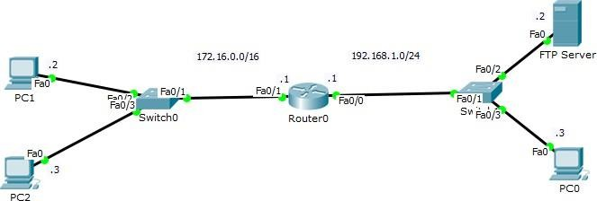

Figure 1

## Refer to figure 1,

Task 1, IP to Router Router>enable Router#configure terminal

Enter configuration commands, one per line. End with CNTL/Z. Router(config)#interface Fa0/0

Router(config-if)#ip address 192.168.1.1 255.255.255.0

Router(config-if)#no shutdown Router(config-if)#exit Router(config)#interface Fa0/1 Router(config-if)#ip address 172.16.0.1

Router(config-if)#ip address 172.16.0.1 255.255.0.0 Router(config-if)#no shutdown

Router(config-if)#exit

# Task 2, IP’s on PC & Server

Now configure given IP’s on PCs and Server and then ping the connections to test complete connectivity.

# Task 3, Activate Ftp services

Activate Ftp services on Ftp Server (as shown in figure 2)

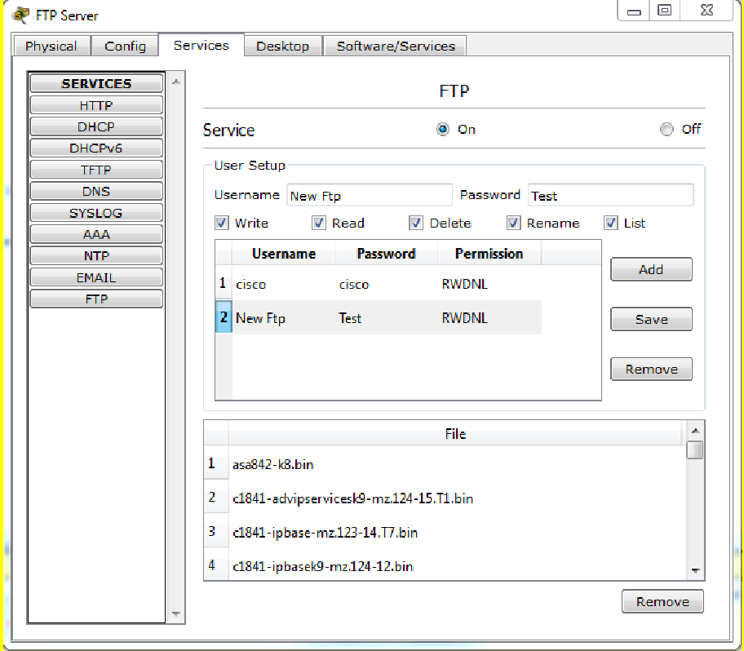

Figure 2

# Task 4, create a text file

Next go to PC0 and open Text Editor and create a .txt file named HelloWorld. (As shown in figure 3)

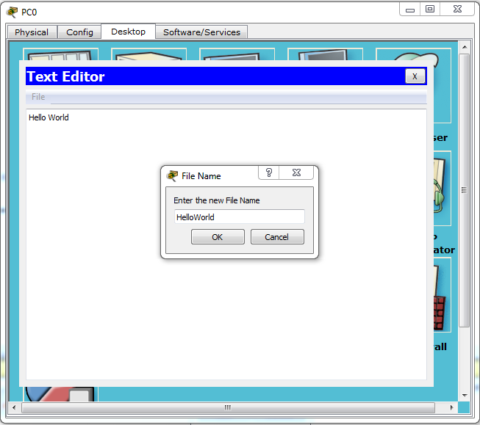

Figure 3 Open the Command Prompt of PC0 and type: PC>dir

Check if your file has been saved to your PC directory. Then connect to ftp server:

PC>ftp 192.168.1.2

Enter the username and password as created. Then type: ftp>dir

Check the directory files on the FTP Server. Then upload your file:

ftp>put HelloWorld.txt

ftp>rename HelloWorld.txt MyWorld.txt

Check on Server that your file has been successfully uploaded. ftp>dir

ftp>quit

Packet Tracer PC Command Line 1.0 PC>221- Service closing control connection

# Task - Rename and Download the Uploaded File

Open the command prompt of PC1 and establish connection with FTP Server. PC>ftp 192.168.1.2

Enter the username and password.

Check the directory and rename the file name HelloWorld.txt to MyWorld.txt ftp>dir

## ftp>rename HelloWorld.txt MyWorld.txt

Renaming HelloWorld.txt ftp>

[OK Renamed file successfully from **HelloWorld.txt** to **MyWorld.txt**] ftp>quit

Packet Tracer PC Command Line 1.0 PC>221- Service closing control connection

Next open the command prompt of PC2 and establish connection with FTP Server to download the recently renamed file.

PC>ftp 192.168.1.2

Enter the username and password.

Check the directory and download the file named MyWorld.txt ftp>dir

ftp>get MyWorld.txt

Reading file MyWorld.txt from 192.168.1.2: File transfer in progress...

[Transfer complete - 11 bytes]

11 bytes copied in 0.01 secs (1100 bytes/sec) ftp>quit

Packet Tracer PC Command Line 1.0 PC>221- Service closing control connection.

Now check that the file is in your PC directory. PC>dir

Volume in drive C has no label. Volume Serial Number is 5E12-4AF3 Directory of C:\

## 1/1/1970 5:0 PM 11 MyWorld.txt

2/7/2106 11:28 PM 26 sampleFile.txt

37 bytes 2 File(s)